**Task 1 -**

Reproduce the following table using CSS positioning (relative or absolute) instead of <table>.

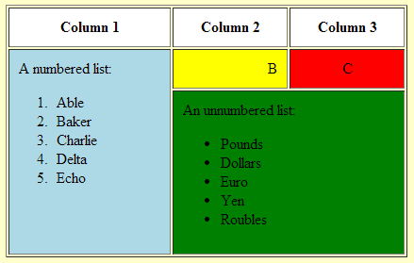

Refer the following sample.

<html>

<head>

<style>

div.blue1 {width:100px;height:200px;background-color:blue;

border-style:none;

position:relative;left:0%;top:0px;}

div.yellow1 {width:100px;height:150px;background-color:yellow;

border-style:none;

position:relative;left:100px;top:-200px;}

div.red1 {width:100px;height:150px;background-color:red;

border-style:none;

position:relative;left:200px;top:-350px;}

div.green1 {width:200px;height:50px;background-color:green;

border-style:none;

position:relative;left:100px;top:-350px;}

</style>

</head>

<body>

<div class = "blue1"></div>

<div class = "yellow1"></div>

<div class = "red1"></div>

<div class = "green1"></div>

</body>

</html>

**Task 2 -**

Write the appropriate CSS to change the presentation of the webpage to that shown in figure below. The new page layout includes a header section, two columns (one for navigation menu and one for the main content) and a footer section.

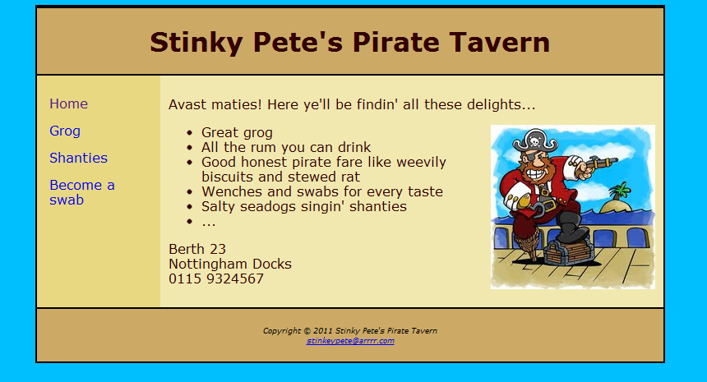

The colours used are as follows:

* Text: #330000
* Body background: #00BFFF
* Header and footer background: #ccaa66
* Left (navigation) column background: #E8D882
* Right (main content) column background: #f1e8b0

The text is displayed in “Verdana” font.

**Task 3- Create the following layout by HTML AND CSS**

